

Foundations of Programming

Assignment No.: 15
PROBLEM STATEMENT: Write a C program to generate pseudo random numbers.

OBJECTIVE:

- To understand the concept of pseudo random numbers.
- To learn the use of rand() and srand() functions in C.
- To generate random numbers using the standard library.
- To understand the role of header files in C programming.

THEORY:
In C programming, pseudo random numbers are generated using the rand() function available in the stdlib.h header file. These numbers are not truly random but are generated using a deterministic algorithm. The srand() function is used to set the seed value for random number generation. Usually, the current time is used as a seed to produce different sequences of numbers each time the program runs.

ALGORITHM:
- START
- Declare variables:
- integer i, n
- Initialise random seed using srand(time(0))
- Input how many random numbers to generate (n)
- Check if n > 0:
- If FALSE → Display error message and terminate program
- Set i = 1
- Repeat while i <= n:
- a) Call rand() and print the generated number
- b) Increment i by 1 (i = i + 1)
- c) Go back to step 7
- STOP
PLATFORM: Linux

INPUT: Number of random numbers to be generated.

OUTPUT: Displays generated pseudo random numbers.

SAMPLE INPUT:
Enter how many random numbers you want: 5

SAMPLE OUTPUT:
Pseudo Random Numbers:
183746
928374
567382
345678
987234

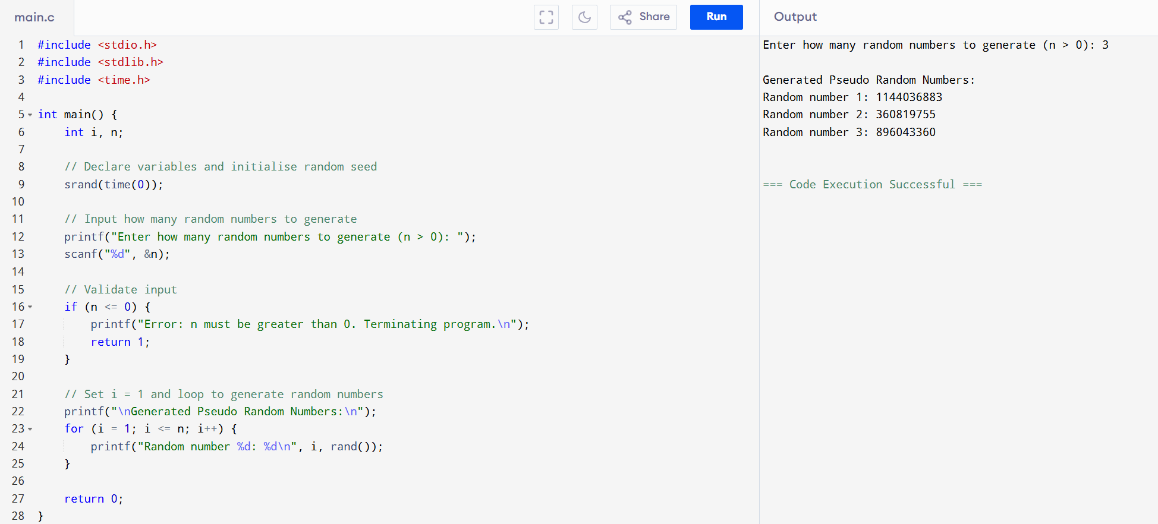
CONCLUSION: Thus, the C program successfully generates pseudo random numbers using the rand() function and srand() for seeding.

FLOWCHART:

